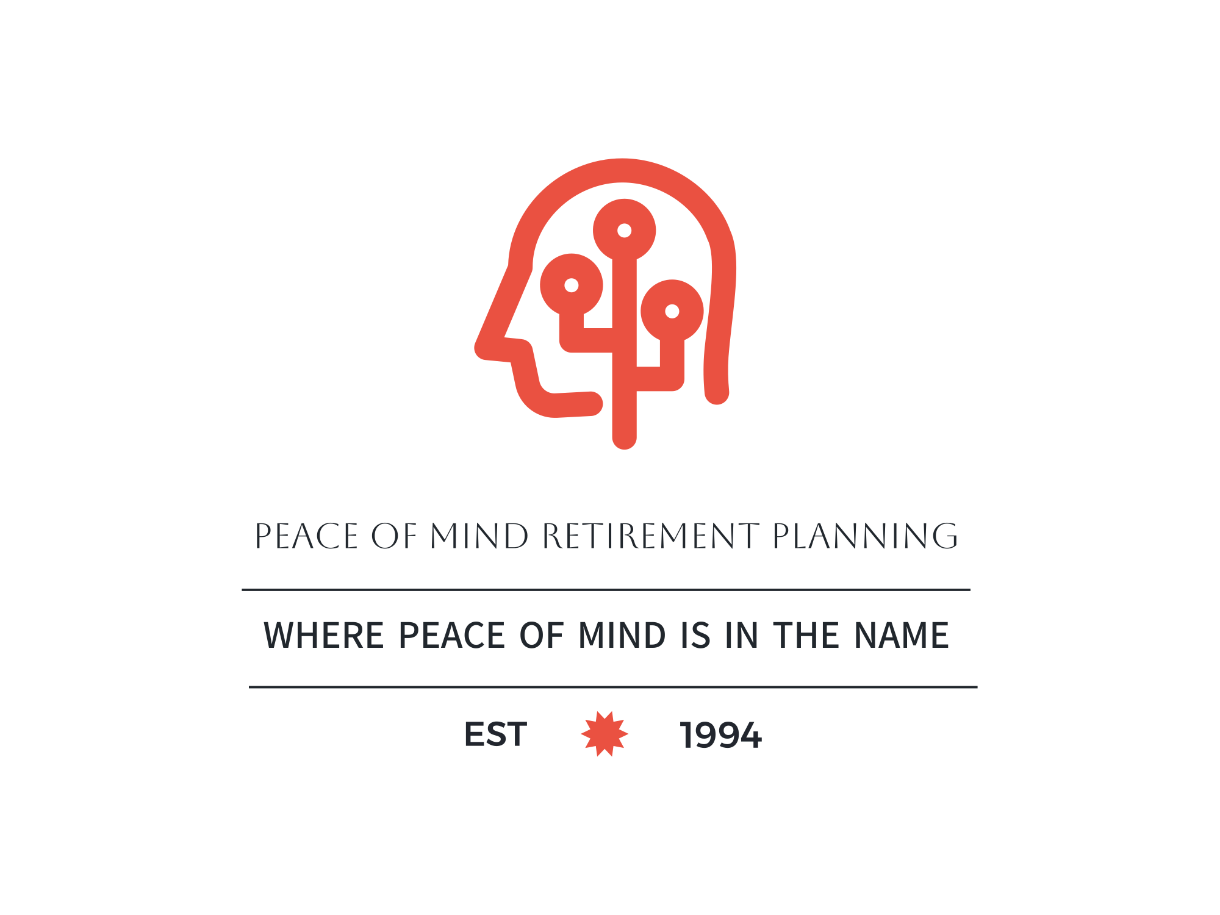

Living Trusts

Estate and Living Trust Planning
In California, estate planning encompasses legal and financial measures that dictate what happens to your assets after you pass away and lays out a plan in case you ever become incapacitated. Estate planning gives your loved ones and caregivers instructions and guidance about your wishes. Your estate plan covers:
- Your property, such as your home and vehicle
- Your assets, such as investments and bank accounts
- Your legacy, such as inheritance and business succession
- Your care, such as appointing a guardian for minor children
Creating a will is only a small part of the estate planning process. While a will provides instructions, it does not protect your beneficiaries from delays and monetary loss during the California probate process.
While estate planning looks different for each person, we recommend a revocable living trust to all clients whose assets are valued at $150,000 or more. We can help you create your estate plan!

Avoid Probate, Save Estate Taxes & Protect Your Family.
What is a Living Trust?
A living trust is a document that creates a legal entity. It is a "living" trust because it remains "alive" after your death.
The trust's purpose is to assure proper management of your affairs during and after your lifetime, even if you become incapacitated.
While you are living you have complete control over your assets. They belong to you as trustee of your trust.
A trust does not pay any taxes or require you to file any extra income tax returns during your lifetime. You file and pay just as you do now, as though the trust did not exist.
A trust gives you control over what happens to your home, bank accounts and personal property after your death.
A trust allows you to specify who gets your assets, under what conditions, and in what manner distributions are made.
A trust can be changed or even revoked entirely during your lifetime but cannot be changed after your death.
You should always consult with an attorney when creating a living trust.

Is a Will Good Enough?
With a will, your chosen agent distributes your estate according to your wishes. However, a will alone will not avoid probate, will not reduce estate taxes, will not make funds immediately available and may result in financial hardship for your family.
Your will is public information and may be viewed in the probate court by anyone after your death. Sadly, the probate process is very slow, often nine months to two years or more.

What Happens If I Die Without a Will or a Trust?
The court will probate all but the smallest estates. This almost certainly includes anyone owning a home.
The probate court judge will appoint an executor to manage and distribute your estate (this person will likely be a complete stranger). Distribution will be made to legal heirs whether you want this or not.
Court, legal, and administrative fees will be taken out of your estate.
If you own a business, activities may be disrupted during probate.
Your family, even while mourning your death, will be burdened with red tape while clearing up your estate.

What Happens If I Die With a Trust?
When you protect your assets and family with a trust, your affairs are kept private and all your wishes are carried out as you instruct. There is no probate, no probate fees, no court or judge involved, and no surprises!

What is Probate?
Probate is a court proceeding that results when a person with assets worth over $100,000 dies without a living trust.
The process is often slow, public and expensive. Your heirs will not have access to your assets until the judge says they can be released. A will alone does not avoid probate.

Is Probate Expensive?
Yes, it is generally many times more expensive than the cost of trusts, wills or other estate planning instruments.
Expensive as it is, the cost in dollars is probably less important than the cost of the emotional turmoil experienced by the family who is left to straighten out affairs that a trust would have avoided altogether.
Costs include court filing fees, attorney's standard fees (and often, in addition, what the court calls attorney's "extraordinary fees"), and personal representative fees. It is not uncommon for fees on an average size estate to be as much as $25,000 or more.

How Does a Trust Benefit Me?
Protects your family from enduring the expense and red tape of probate.
Avoids having a judge determine how your estate will be distributed.
Reduces or eliminates the need for the court to appoint a conservator if you become incapacitated.
Allows your chosen successor to arrange for your long-term care.
Reduces or eliminates estate tax (for couples) by preserving and utilizing your federal estate tax exemption after your death.
Allows you to maintain control over your assets while you are living and to control the distribution of your estate after your death.
Gives you peace of mind, knowing that you have a plan in place that benefits you now, and your family and heirs after your death.

What Documents are Included?
Our estate plan contains a complete set of documents including, where needed:
- Pour-Over Wills
- Power of Attorney for Property
- Revocable Living Trust
- Advanced Health Care Directives
- Community Property Agreement
- Certification/Abstract of Trust
- Guardian Nomination
- Pre-Addressed Funding Letters
- Deeds, PCORs and Instructions>
Please contact us today to receive additional information or to start your estate planning. We will guide you through the planning process from start to finish, and we know from experience that you will feel satisfied and relieved once your plan is in place.

